Project | PR-118
Date | 2025-01-18
 | MP Filtri UK Ltd
Author | JMD

11171 Software Development

TODO
- Auto-adjust button to calibrate to any given test result(s)
- Make tickbox work for raw/normalised counts
- check NAVAIR standard on LPA3 re coloring etc
  - use true 10um count
- *load*/save settings from cal view
- quick export of multi-portion test counts and extended counts

Created 11171 branches of LPA3 and LPA-View code.
Concept: add required features to LPA3 codebase. The various particle counter models [LPA3, CML4, CML3, ref_ctr] are "views" into these facilities. For example, convert particle counting code to always have say 32 channels.
Alternative: Minimum change
- 8 sizes as now {4,6,14,21,25,38,50,70} um(c).
- 4 extended sizes {4.2, 4.6, 6.4, 10.0} um(c).
- 8 channels temporarily loaded with alternate thresholds during calibration.
  - Annex A&E from table A.1 {4, 5, 6, 7, 8, 10}
  - Need to be able to keep these around somewhere though
- Could have {4, 6, 14, 21, 25, 38, 50, 70, 4.2, 4.6, 6.4, 10.0, 5, 7, 8, 30}
Idea: Dynamically interpolate the NAVAIR 10um threshold during result calculation.
Thresholds are the SRM2806 ones plus those required for NAS etc.
{4,5,6..29,30, 38, 50, 70} um(c) = 27+3 = 30 channels

Notes
- Need to be able to prove full 11171 on both Reference and LPA4 counters including annexes. However LPA4 can use certified test rig distribution.
- Can have button on LPS-View LPA3 Calibration screen to write distribution to reference
- 11171 Primary calibration requires 3 separate bottles of SRM2806 be used. This makes it difficult to have automatic threshold setting. Since would need to consistently maintain 3+ histograms, with any error risking loss of data. Also need to be able to remove test portion outliers as required. For this will need capability to export counts to spreadsheet to generate a calibration curve, then manually or automatically enter interpolated thresholds.

Thresholds
Conclusion: float representation useful but not required. Need 16 SRM2806x +PSL sizes.
- Annex E: 6 of RM8632x sizes = {4, 5, 6, 7, 8, 9, 10}
- Annex F: 16 of SRM280x sizes = { 4, 5, 6, 7, 8, 9, 10, 12, 14, 15, 16, 18, 20, 21, 22, 25 }
- Clause 6.11 PSL spheres >30, k<1.5 = {38, 50, 70} = +3
- Minimum 19 threshold points need to be stored.
- 4..25 + 30,38,50,70 = 26 sizes.
- Reasonable to have 32x thresholds (26 as above + 40, 60 + 4 spare)
- Each threshold {mb_f2_t size, float threshold} = 6 bytes.
- Implementation: Using plain floats for both {size, threshold}

Certified 11171 secondary suspensions (Annex F) need to list at least 16 sizes from the SRM2806x distribution. Our primary counter should therefore have at least 16 sizes in this range as well as some larger ones for use with PSL spheres.
Partistan 2806 reports 16 measured sizes with the rest produced via interpolation.
Secondary calibrated particle counters can have less but Annex E requires testing a RM8632 sample and counting at least 6 sizes from table A.1 {2,3,4,5,6,7,8,9,10}. We therefore do need to calibrate at these sizes and save/reload the thresholds somewhere.
For GOST support (and possibly reworked standards based on microscope measurement of longest chord length like NAS) we used SRM2806:2000 to define the relationship between largest particle dimension per ISO4406:1987 and equivalent projected area per ISO4406:1999+
1um = 4.2um(c) (SRM2806:2000)
2um = 4.6um(c) (SRM2806:2000)
5um = 6.4um(c) (SRM2806:2000)
10um = 9.8um(c) (SRM2806:2000)
15um = 13.6um(c) (SRM2806:2000)

GOST reports chord sizes equivalent to 4.2, 4.6, 6.4, 13.6 um(c)
However we can more easily use on-device threshold interpolation to generate these if desired rather than defining dedicated thresholds.
For NAVAIR we need 5,10,25,50,100μm sizes i.e. it adds the 10μm size [= 9.8μm(c) can just use 10μm(c)].
Also Annex B Coincidence require setting a threshold
"corresponding to 1,5 times the threshold noise level of the APC or corresponding to the smallest particle size of interest if it is greater than 1,5 times the threshold noise level."
(This also implies that the smallest particle threshold does *not* need to be >1.5 times the noise threshold. However elsewhere 11171 contradicts this e.g. F.4.a).
Annex D Resolution uses 5 channels that can be adjusted arbitrarily to centre the sphere size but can be done another way if available (e.g. using MCA directly).
Latex sphere calibrations using interpolation require a logarithmically spaced series however if we can obtain spheres close to the desired sizes then we can just use these.
Clause 6 does say to use all available certified SRM2806 sizes and a minimum of 16 however this is for use in interpolating a "calibration curve" which we do not do since we instead set thresholds to the exact optimum value to obtain the desired counts i.e. we are a MCA.

Threshold resolution
Currently 0-65535 where 65535 is a notional "full scale" pulse. These are divided by 4 to match the ADC range of 16384 ADU.
They are further scaled (multiplied) by a factor to account for the measured LED level as a fraction of the circuit maximum. So any variation in LED output does not affect the particle counts.
t->threshold_scale_factor = s->led_level / hw_photocurrent_full_scale_nA();
NB the amplitude of an ADC full scale pulse is different from the LED output since it is determined also by the photodiode preamplifier gain which is empirically chosen to have the 70um threshold in the upper half of the range.

Small Sizes
For the reference counter unit we have a 4um threshold of e.g. 148/27ADU (at 10ml/min).
The fractional threshold setting resolution would then be 1/148 = 0.7%.

Large Sizes
Here we have relatively fewer particles (although supposed to be >1000).
These will likely be distributed over 1000's of bins so probably only 0 or 1 particles in a bin.
Threshold with x4 scale factor will then be able to resolve ¼ of a raw count.
Issues arise with non-PSL sphere calibration where they may only be 168*0.07 = 11 particles. ¼ particle resolution would then be about 2% in count → OK.

Threshold Resolution – Conclusion
It does seem like higher resolution would be useful but not required.

If made thresholds floats then could keep scaling similar i.e. 0-65535.0.

How many Channels - Counts
Need raw particle counts or at least to know if >10000 for the smallest size and >1000 for the largest. (For reporting ISO4406 codes also supposed to know if <20 particles).
If make available the volume actually scanned then we could keep reporting the count per 100ml = count_{RAW} * 100ml / v_{SCANNED}. Raw count would then be count_{/100ml} * v_{SCANNED}/100ml, rounded to nearest integer. This seems to preserve precision for v_{SCANNED} < 100ml.
Can just use floats for counts and for volume scanned. That way can reconstruct raw counts exactly as long as not doing anything like clipping correction (where the volume varies by count).
Conclusion: Will use array of 32 floats plus a float for scanned_ml.

Histograms
The LPA3 calibration performs 3x100ml samples accumulating a histogram. It prints intermediate results but in fact these are from the accumulated histogram rather than individual tests.
The reference counter has a multi-portion sample within one stroke that we intend to use for the calibration, outputting distinct counts for each portion. Here we do not have an accumulated histogram so the calibration would be based on just one portion.
We need a separate histogram for intermediate and accumulated counts.
After a series of tests or test portions, the accumulated version would be used to obtain the thresholds.
Possibly this could be a "recalculate" command without having altered any thresholds. i.e. the recalculate command would always operate on the accumulated data.
Need to either make current histogram implementation have dual sets of bins or else encapsulate so that can have two instances.
We have something already in the icu project.

Modelling & Simulation
Switch to direct population of the pulse height histograms. Model SRM2806d distribution
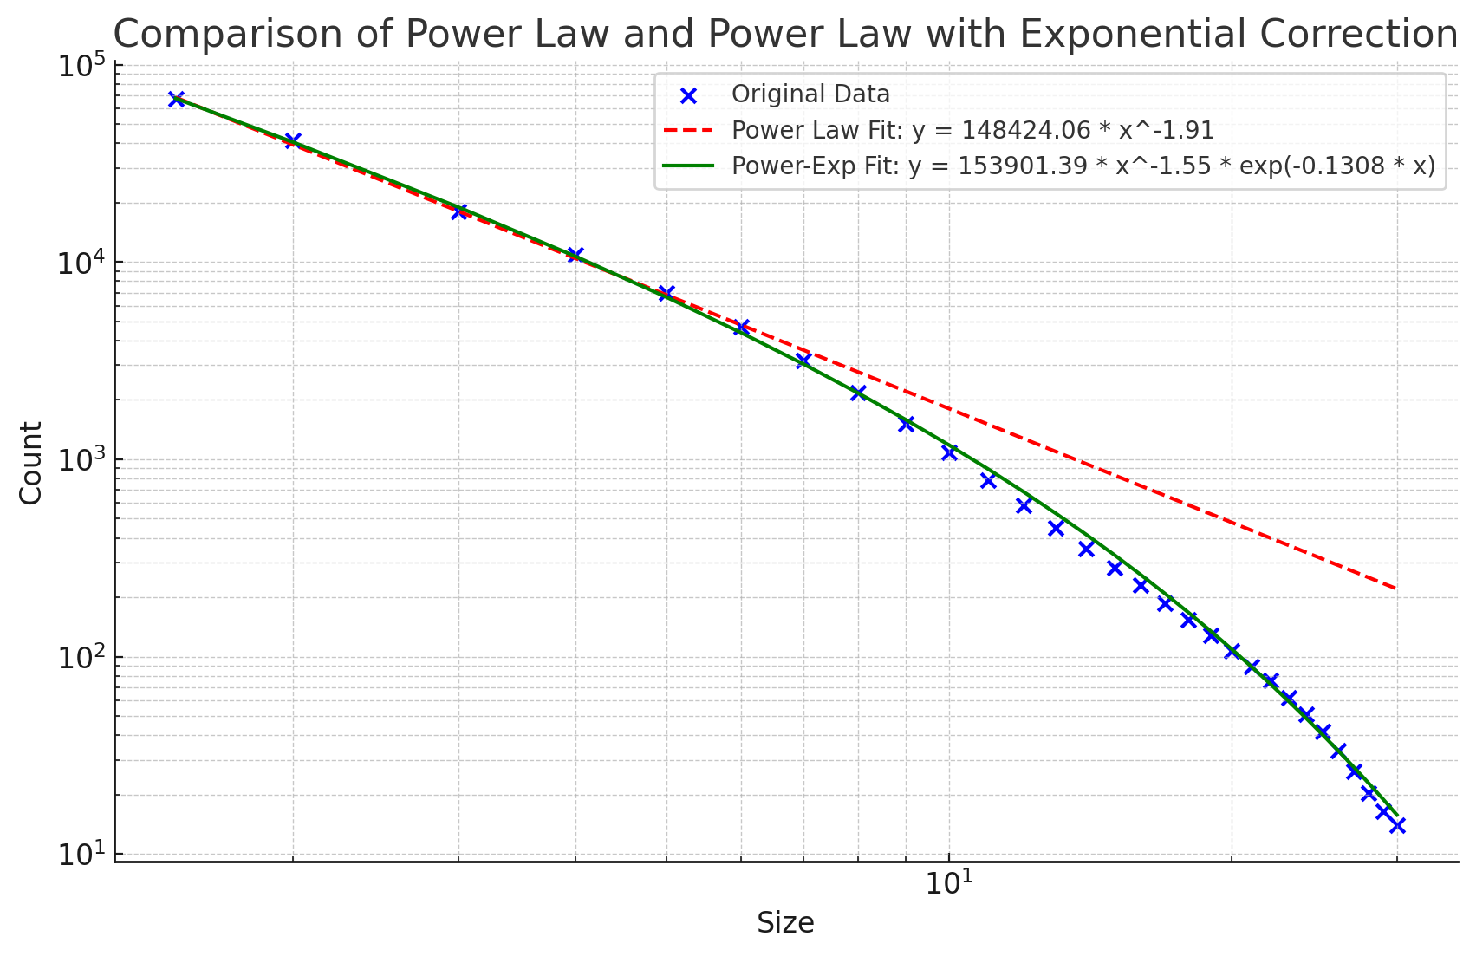
The cumulative particle distribution can be modelled using a power law for the small sizes with an exponential correction to account for the fall off at larger sizes. This has the form:
f(x)=A⋅x^{−α}⋅e^{−βx}

Assuming pulse heights proportional to equivalent circular projected area, for a 16384 channel histogram with 14um at bin 231 and 800000 particles >4μm, the equation to model the histogram counts is
n(B) = 13683.13 * B^(-0.275) * exp(-0.08774 * sqrt(B / 1.1786))

Thresholds, Scaling, Dynamic Range
4μm particles had thresholds of 148/65536 scaled by 5.4 (x4 for bit shifting and x1.35 for photocurrent scaling). 30μm would then be 148 x (30/4)^2 = 8325.
If use 14um threshold of 1248 as a base. 4um would be 101.
 | 4 | 6 | 14 | 21 | 25 | 38 | 50 | 70
ADU | 27 | 51 | 231 | 525 | 752 | 1697 | 2348 | 3645
Calibrated | 148 | 280 | 1248 | 2840 | 4066 | 9166 | 12684 | 19688
Predicted | 102 | 230 | 1248 | 2808 | 3979 | 9194 | 15918 | 31200
Spheres ADU |  |  | 10um  250 |  |  |  |  | 5248
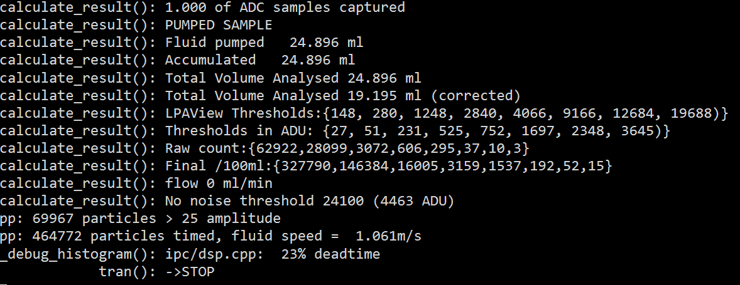
This gives very good agreement between 6μm and 38μm. 4μm maybe higher due to SRM2806 "correction" or because small particles scatter disproportionally more light. Large sizes may be lower because there are not as many of them as assumed or because they approach the slit width so transition from being proportional to area to being proportional to diameter instead.
The 70um sphere result indicates should increase gain of circuit x2. DONE see R2-20 variant.

Annex E
Requires counting at least 6 sizes from table A.1 {2,3,4,5,6,7,8,9,10}
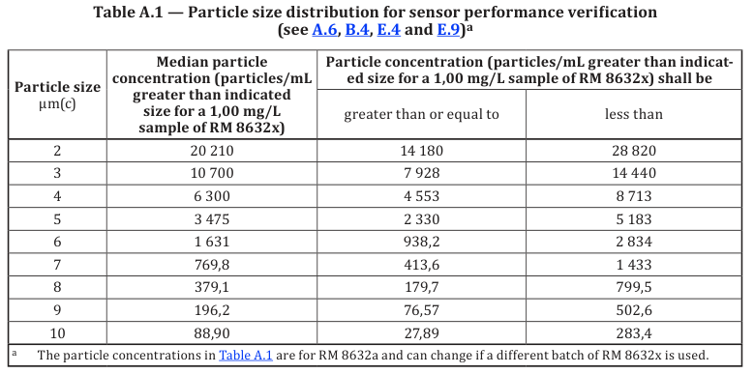
Specifies 3 bottles of 1.0mg/l RM8632
5x10ml from each one
C_{V} within limits of table C.2.
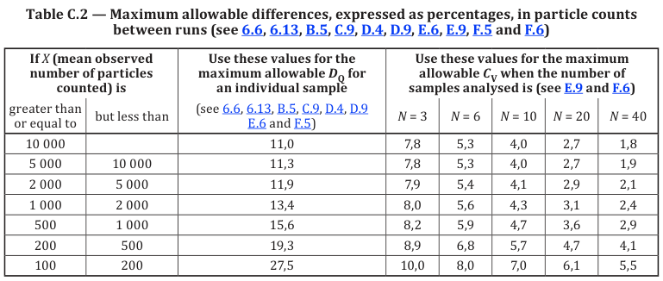
→ requires obtaining raw particle counts (by calculation potentially?)

2025-02-01
Implemented pulse simulation in hardware using MXO5 arb programmed with random gaussian pulses. Works but would be better recording a live signal or just filling the histogram with a simulated distribution.

2025-02-02
Focus on updating codebase for fuller-featured reference counter.
Can fix-up other models like CML4, CML3 to use these features in the future.
For example make particle counting 32 channel, calibration from a known distribution.
Coding systems and counts display take counts from particular channels.
The channel boundaries can be integer micron sizes since that is what
GOST that use the 10um channel​​​​​​​

2025-02-14
- Test cycle to perform N portions and integrate results at the end
- Each portion is individually analysed based on its volume and logged and reported.
- Each portion histogram added to total histogram. Each portion sample volume added to total accumulated
- After last histogram is analysed then need to perform analysis on total.

Migration

Threshold Migration
Auto-interpolate extended thresholds when install firmware, if these are empty.
Extended versions of cardinal sizes 4,6,14,21,25,38,50,70 will be identical to existing ones. Intermediate values will be reasonably good guesses and only matter for 10um for UI.
Existing LPA-View will still see old thresholds.
Could run in parallel?
New cardinal sizes extended thresholds could also be written to legacy ones by new LPA-View calibrations.
Allows for gradual migration of UI etc to use new counts

Counts
Existing CML-View will see old counts

Need to ensure not used with new firmware?

Logging

Minimal Implementation for NAVAIR Prototypes
Have a hard deadline of May 16th 2025 to ship these.
Need to produce sufficiently accurate results with 3.5mg/l RM8631 and also pass 11171 Annex E (RM8632a) limits.
- Use normal "auto-adjust" method to calibrate to a manually entered distribution measured by reference counter. Distribution can be measured by a counter then manually typed into reference distribution grid. Just need values for the 9 measured sizes.
- Don't implement 32-channel calibration / counting for the NAVAIR units
- Add coarse test dust to MTD to produce more large particles to calibrate to (need to verify method).
- Check printouts for NAVAIR since these will be used extensively
- On-screen history / recall needs to work

What to do for 10μm threshold
- First attempt at navair standard interpolated the 10μm counts
- Need to at least interpolate the threshold instead and calculate + store. Can use threshold32[6] to store this (the new threshold for 10μm)
- Then need to store the count too. We already are calculating raw count [6].
- detect calibration event and write an interpolated 10μm extended threshold to [6].

Compatibility
Make sure test cycle is fit for this model
- 30ml/min for all modes
- Single portion mode only except in diagnostic mode

2025-05-10 Calibration Plan 12 Samples
D2 now seem to be requiring sphere calibration. Were hoping to use coarse test dust however there are still very few particles of the larger sizes.
So need to calibrate to a distribution for 4-21, then spheres for 38, 50, 70.
Want to be able to update the program-wide distribution from a reference counter measurement.
Can then calibrate attached LPA3 units to the measured distribution for 4,6,14,21,25μm sizes.
CHECK HAVE CORRECT FLOW CURVE SETTING (0)

Possible Workflow
- Load newest snapshot of software onto a calibration bench computer in own NAVAIR folder
- Also release snapshot of firmware
For each unit
- Update firmware
- Initialise system settings. Enter serial number.
- Flush unit with bottle sampler unless done already
- Perform noise check to set initial LED level
- Calibration run on dosed rig to 6mgl MTD assumed distribution (until reference counter ready)
- Manually set 38, 50, 70 μm thresholds to fixed values TBD
- Export calibration data to spreadsheet

*

